Six Nations Rugby Prediction Assignment

This assignment is meant to provide you with an alternative context where you can further develop the skills you have learned. These assignments will deliberately be focused on a setting where you do not have a lot of prior expectations about the outcomes and must look at data to make recommendations.

The Setting:

Analytics and big data are a growing phenomenon in professional sports.

The Six-Nations Rugby Tournament is an annual rugby competition between England, France, Italy, Wales, Ireland and Scotland that runs from Saturday February 3 until Saturday March 17 2018. There are five rounds in each tournament in which there are three games each. Every team in the tournament plays every other team and receives points for wins, draws with bonus points being awarded if a team wins or does not lose by a large margin.

A full history of the tournament and information about the rules, venues, etc. is available on Wikipedia (https://en.wikipedia.org/wiki/Six_Nations_Championship ). Information about the matches in this year’s tournament along with information about past matches is available here (https://www.sixnationsrugby.com/fixtures/ ).

The Assignment:

Imagine that you have walked into a sports analytics company on the first day, and they have asked you to provide insight into who will win the Six Nations tournament and what will be the outcome of individual matches.

You might not be an expert on Rugby, or even know the rules of the game. Maybe, you have never even heard of Wales. However, to make a good first impression in your new company, you will have to deliver on this project. You might not bring a wealth of rugby experience, but you can look at the data, make predictions and justify those predictions.

Where to Start:

Tasked with a (deliberately) vague prompt such as this, where you have not been given a dataset or specific tool to use, you do as any good intern would. You agree to deliver the predictions, then try to figure out what you need to do.

Here are some ideas to get you started.

- If you do not know anything about the tournament or rugby in general, read about the tournament on Wikipedia or watch a Rugby Union game online to see what it is all about.

- Get a list of the fixtures for which you will have to make a prediction. (You can find the official list here: https://www.sixnationsrugby.com/fixtures/

- Make a list of potential “data points” that you can collect that could help you predict who will win the Six Nations tournament.

Some examples are:

  - What has historically been the winning percentage of each matchup (Team A vs Team B). This tournament has existed since 1883 so there is plenty of data on head to head matchups.
  - How much more are they likely to win at home? How much more likely are they to win away?
  - Who has won these matchups in the last 3, 5, 10 meetings?

- Expand the list by adding to each of these what might be the easiest data source that can help you answer this question.

For example:

  - (example a from above). You could do a google search for historical rugby data on matchups. You would find sources like RugbyData.com which can provide you with information about the winning percentages in these matchups, point differentials, etc. You could click through to the individual matchup pages that contain this information on the official six nations website.
  - (example c from above). You could do a Google search for individual player data. You would find sources such as (http://rugby.statbunker.com/players/GetHistoryStats?player_id=16650 ).

- Think about what would be the most important predictive variables, and the easiest to collect.

For example, you may be able to make a prediction about who will win each game by looking at the historical data. The player data may not be easy to access until you have learned how to do web scraping or collapse large datasets.

- Start by trying to predict the outcomes of the first few matches. You have a few weeks until the predictions are due and you can update these predictions as the class progresses.

Things to keep in mind: You might feel disheartened as you start working on this project. You may feel as if you do not know what you are doing. You don’t know if winning percentages are a meaningful predictor. You don’t know what variable to look at. You don’t know what really determines success in Rugby. Do not worry! Working with data is looking into a great unknown and there is never a single right way. However, if you keep thinking about how to solve the problem you are tasked with you will get there eventually. There is a famous quote by Robert Coase, a Nobel Laureate in economics, that you can keep in mind as you are doing this: "If you torture the data long enough, it will confess."

The entire purpose of this exercise is to put you in a situation where you have a desired objective, but you need to find a way to navigate the path of thinking about data, collecting data and analyzing the data. The uncertainty surrounding this task may seem unusual. However, this will prepare you for working on the final project, and will prepare you for when you encounter uncertain tasks in the workplace.

Deliverables:

There will be five rounds of six nations games played on the following dates.

Rounds | Predictions Due | Report / Check In-Deadline
#1 | Friday, February 1, 2019 | Friday, February 1, 2019
#2 | Friday, February 9, 2019
#3 | Thursday, February 23, 2019 | Thursday, February 23, 2019
#4 | Friday, March 9, 2019
#5 | Friday, March 16, 2019 | Friday, March 16, 2019

You will be asked to submit predictions via blackboard before Feb 1. You are welcome to submit updated predictions before each round. You cannot submit predictions retroactively after a round has passed.

Grading:

You will be graded based on the accuracy of the prediction and the level of analysis that you provide. You will be required to submit a short 1 – 2 page summary of your approach. You will be required to submit the report by the end of the tournament on March 16, 2019.

The writeup will be weighted 50% of the project grade. The accuracy of the prediction will be weighted 50% of the project grade. The prediction will be calculated as follows:

Accuracy = Total Correct Outcomes Predicted / Total Matches

Your assignments will be graded based on the following rubric where grades will be assigned on a scale of 0 – 2 with 0 indicating does not meet expectations, 1 meets expectations and 2 exceeds expectations, rate each person on each of the five criteria.

Writeup Assessment Criteria | Grade (0 – 2)
Did the student justify the data points that were included in the analysis.

Did the student justify the data points that were not included in the analysis.

Rationale and interpretation of these data points.

Total (out of 6)

Using Python or Other Tools: You are encouraged to use the python skills taught in the workshops to work on your project. However, there is no requirement that you must replicate what was done in the python workshops on the take home assignment.

Here is what I’ve done so far.
1, In order to structure my approach a little bit more, I asked the questions about the matchups, the teams, and the players. I will see if it’s needed to add more questions along the way.

1 Matchup Data
1.1 What are the possible matchups (Team A vs Team B)
1.2 What has historically been the winning percentage of each matchup (Team A vs Team B).
1.3 What is the winning percentage, historically, of a Home team win the matchup?
1.4 What is the winning percentage, historically, of a Guest team win the matchup?
1.5 .Who has won these matchups in the last 3, 5, 10 meetings?
2 Team Data
For each team, what are their Home matchup winning rate?
For each team, what are their Guest matchup winning rate? (all winning matchups and percentage)
At each matchup, for each team, what is the historical winning rate? Losing rate? Home or guest?
3 Player Data
For each team, what are the member list
match with matchups and winnings
--to see if there any significant correlation between a single player and the winnings.????

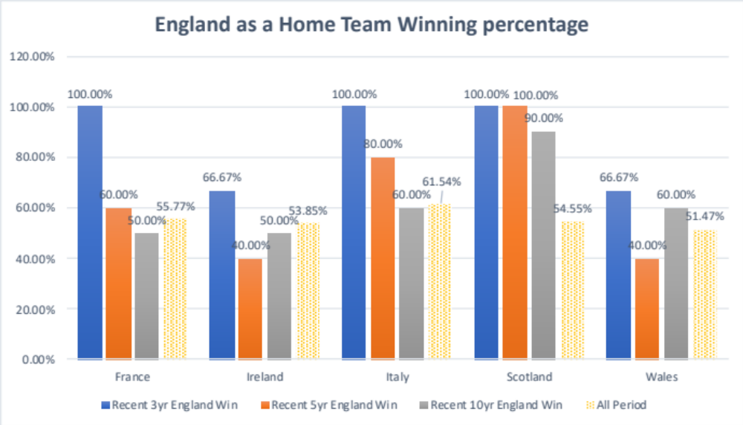

England (Home) vs. Scotland (Away) very likely England will win

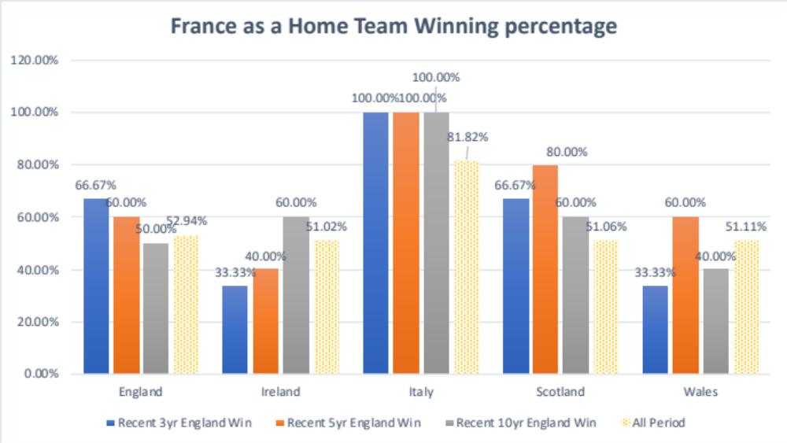

France (Home) vs. Italy (Away) almost sure France will win

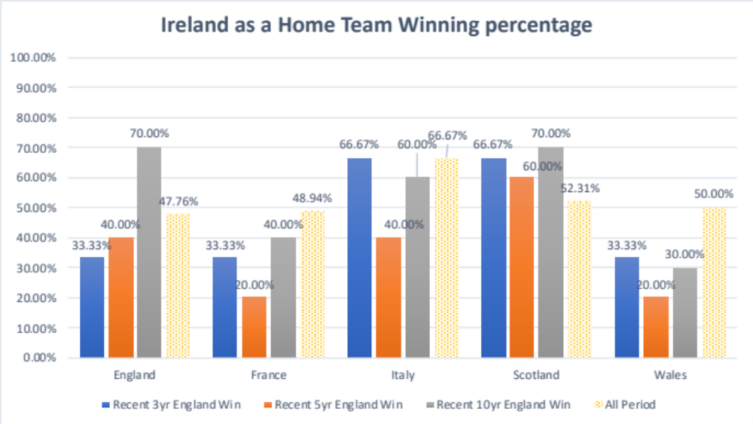
If there is draw data and players change.

